**Linux Operating System:**

**History:**

1960 – multics – Tenenbum – B programming

ATnT – Dennis Ritchie and Ken Thomson

1970 – C programming – Unics – UNIX

1980:

IBM – AIX – works only on IBM hardwares

HP – HP-UX

Sun – Solaris

1992 – linus Torvalds – Linux

1. Open source
2. It works on any hardware
3. More security
4. Stability

xxxxxxxxxxxxxxxxxxxxxxxxxxxxxxxxxxxxxxxxxxxxxx

IBM – DOS – bill gates

Windows

Xxxxxxxxxxxxxxxxxxxxxxxxxxxxxxxxxxxxxxxxxxxxxxxxxxxxx

OS Architecture:

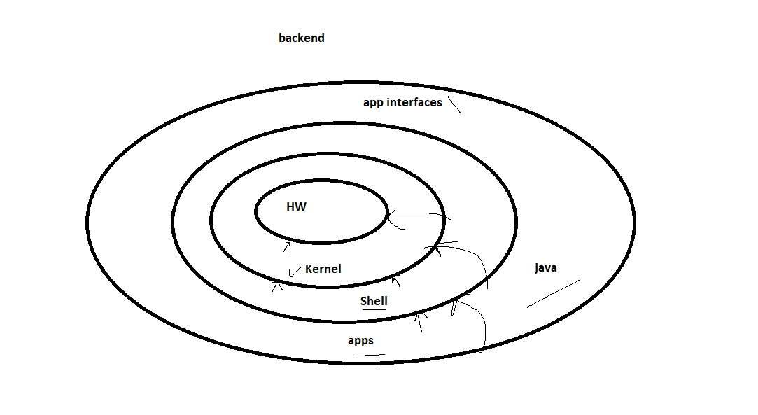

**Kernel** – Manager of OS

**Shell** – It’s a command line interpreter between user and HW

xxxxxxxxxxxxxxxxxxxxxxxxxxxxxxxxxxxxxxxxxxxxxxxxxxxxxxxxxxxxxxxxxxxxxx

Deploying Instance in AWS – EC2

1. Create Security group:

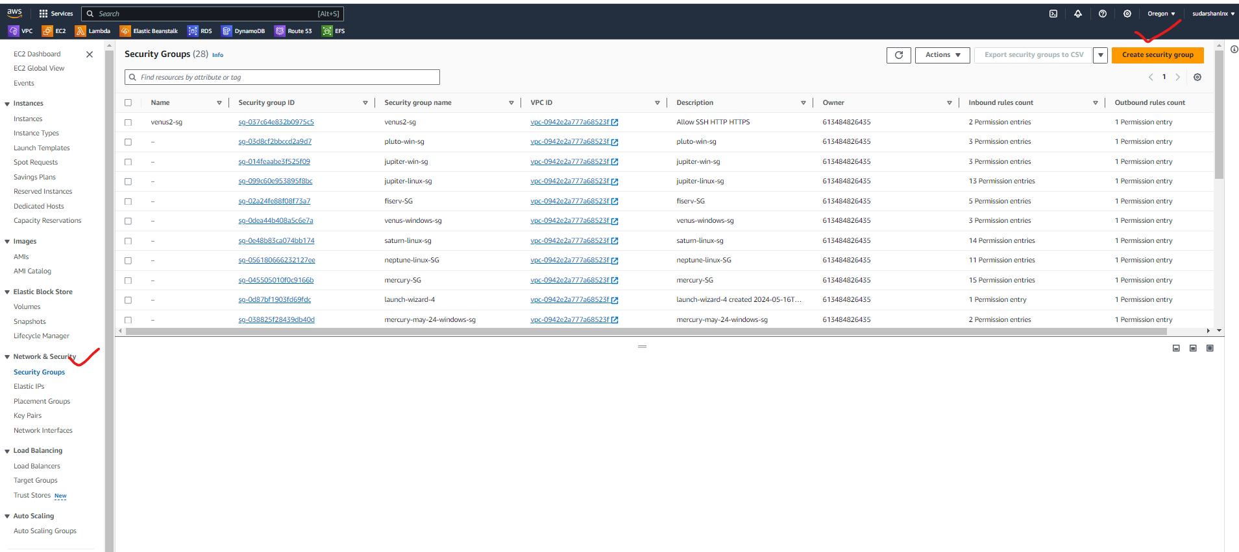

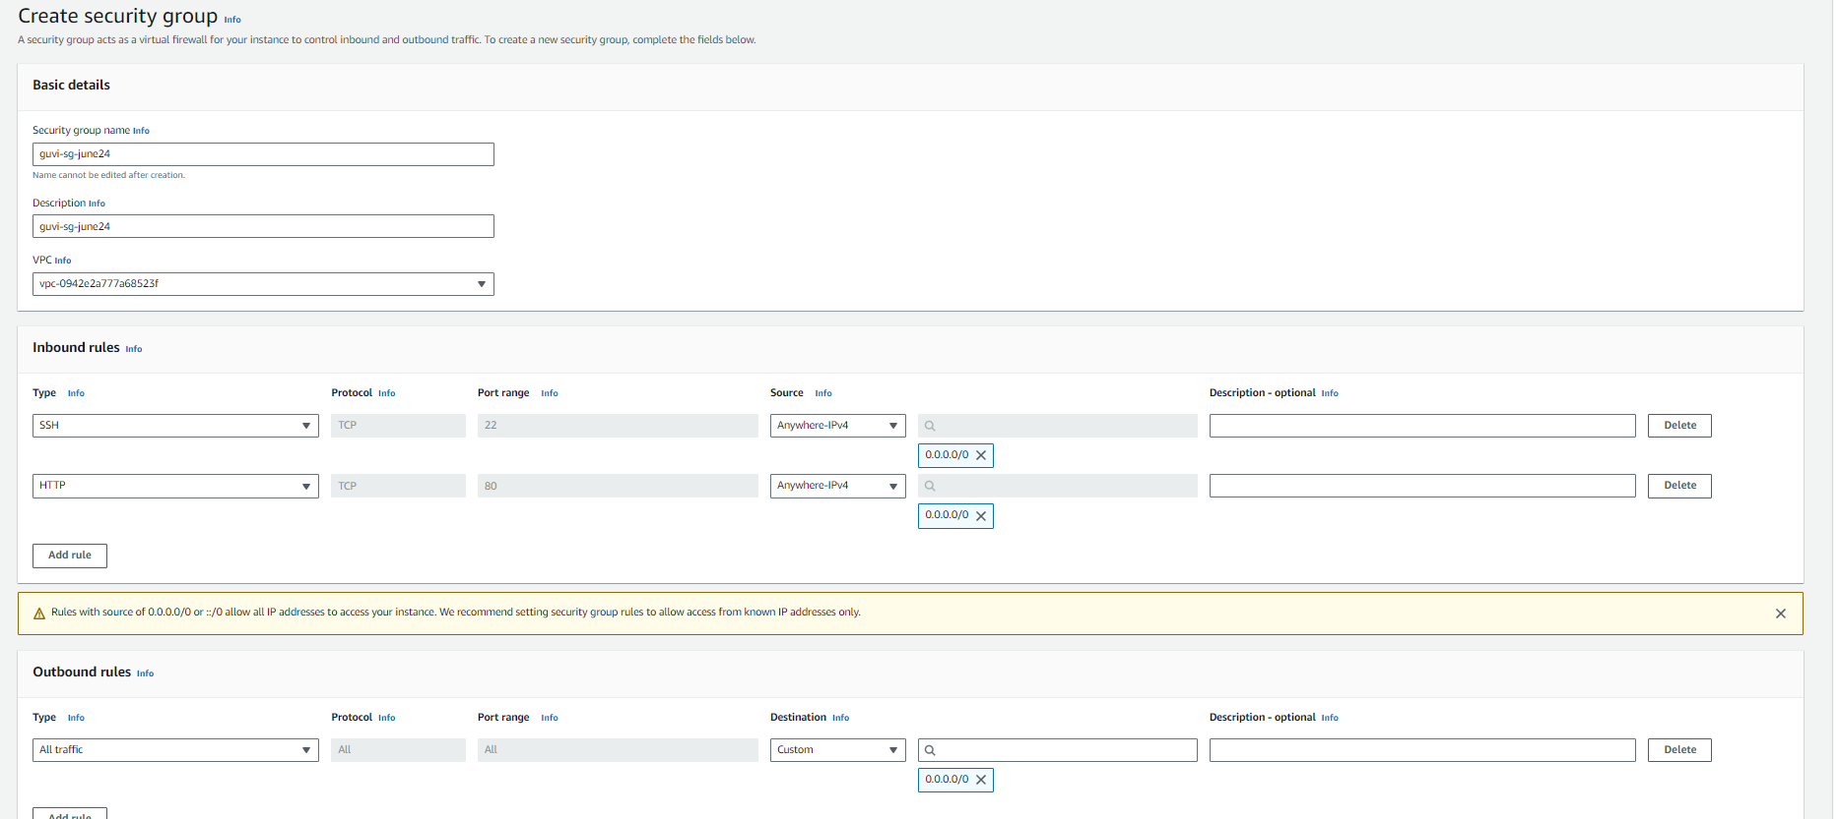

1. Search EC2 and select Launch Instance

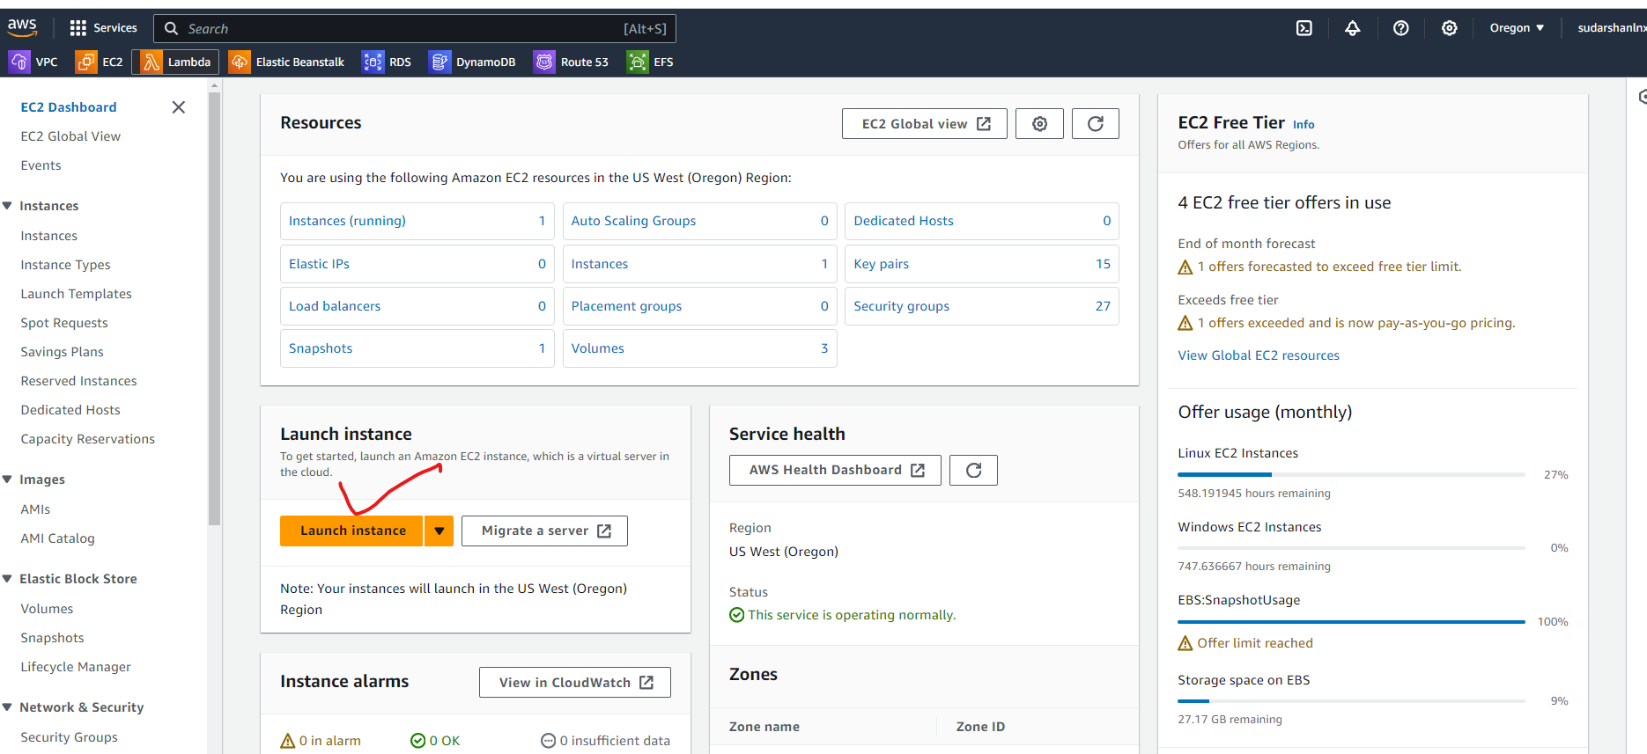

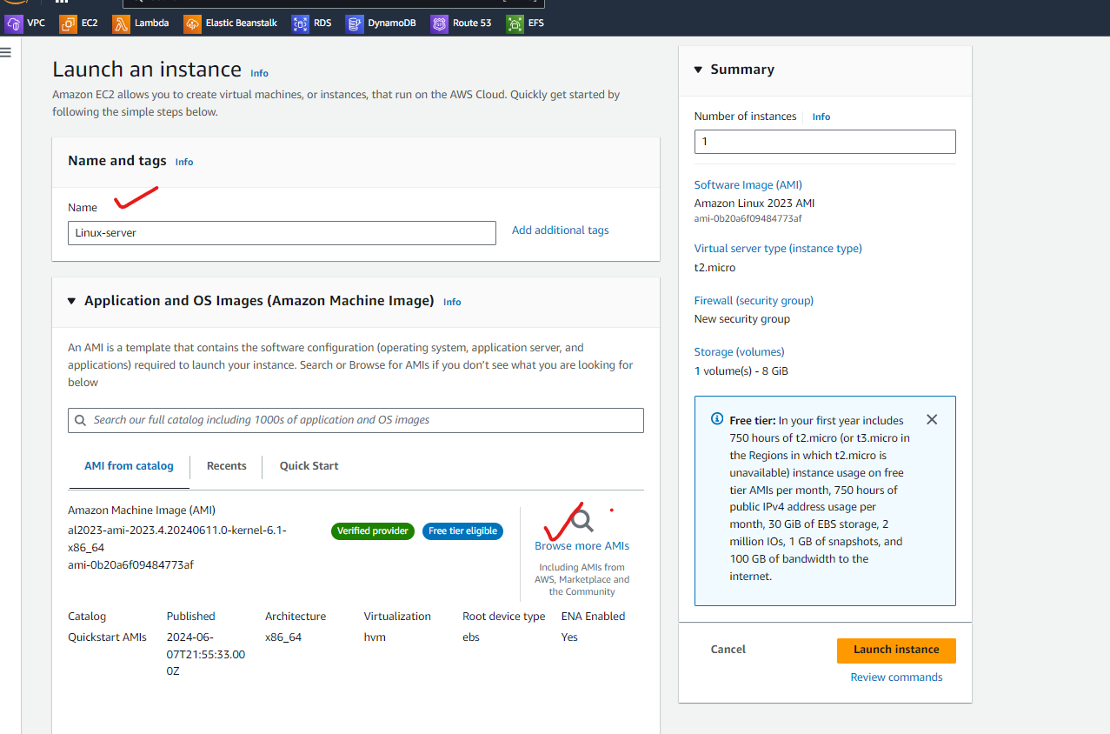

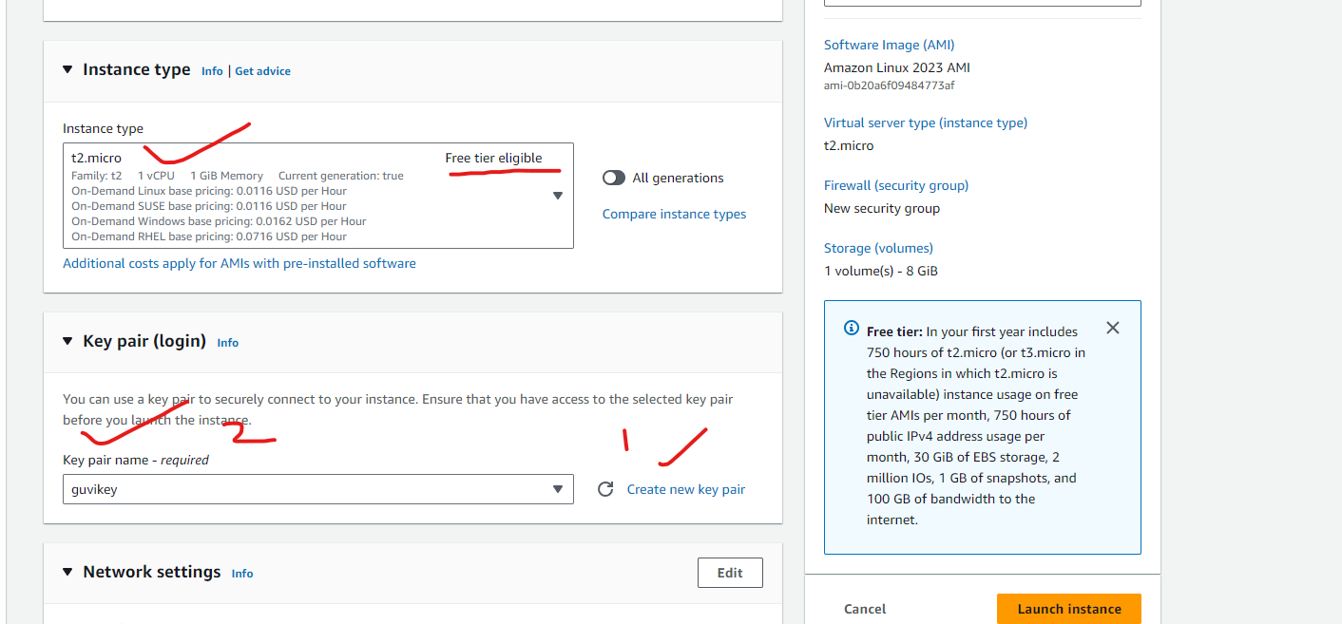

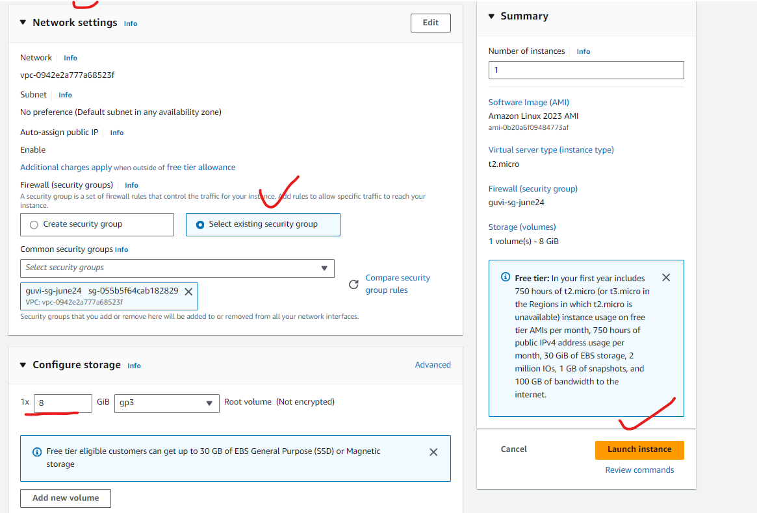

Now download Mobaxterm to connect Linux server :

<https://mobaxterm.mobatek.net/download-home-edition.html>

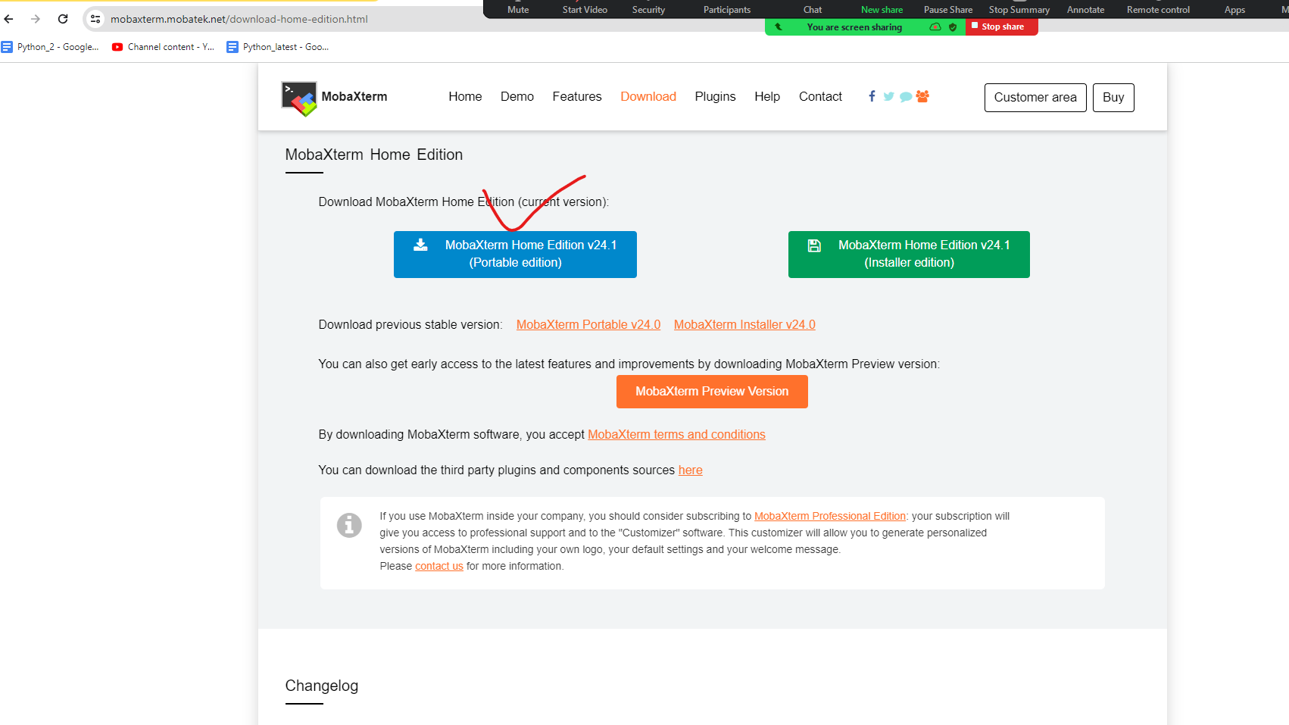

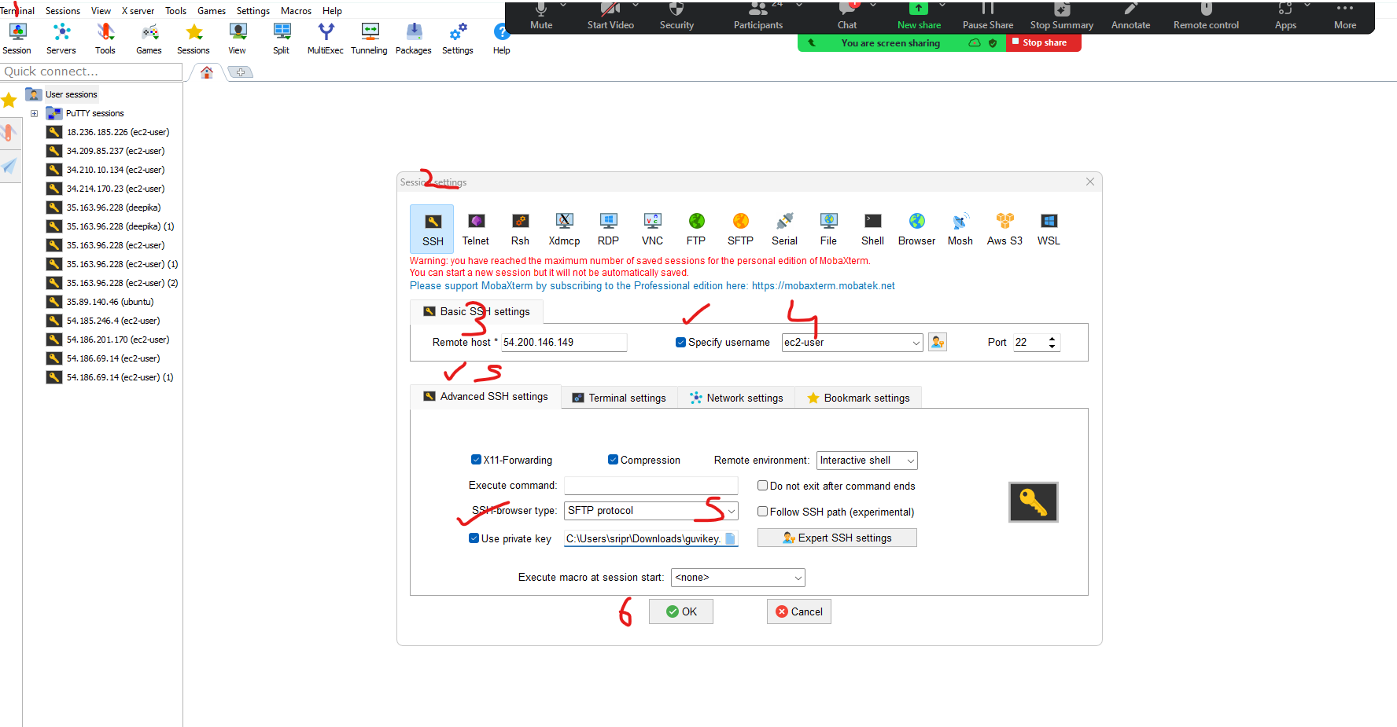

To terminate the AWS instance:

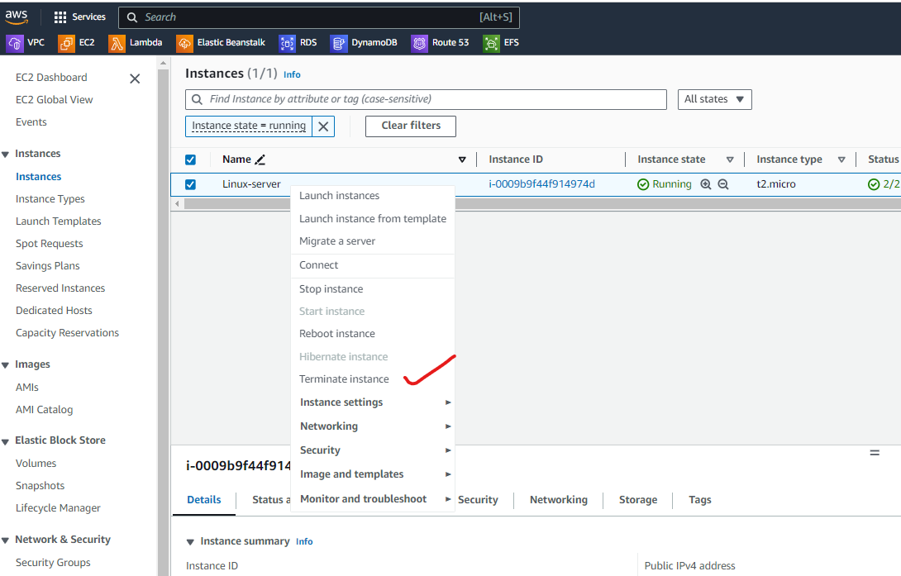

Xxxxxxxxxxxxxxxxxxxxxxxxxxx

Method: WSL – Windows Subsystem for Linux

#dism.exe /online /enable-feature /featurename:Microsoft-Windows-Subsystem-Linux /all /norestart

#dism.exe /online /enable-feature /featurename:VirtualMachinePlatform /all /norestart

#wsl --set-default-version 2

if the above command failed down the package directly from the wsl site:

download this package:

https://learn.microsoft.com/en-us/windows/wsl/install-manual#step-4---download-the-linux-kernel-update-package

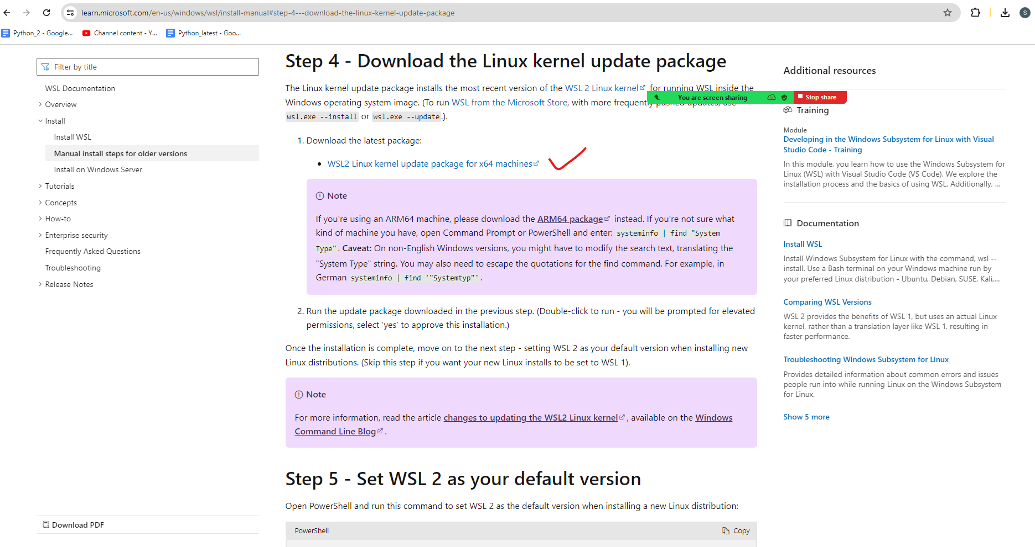

to check all the available OS:

#wsl -l -o

To install a specific OS :

#wsl --install -d OracleLinux_9_1

To directly login to a available linux server :

#wsl -d OracleLinux_7_9

To logout from linux:

#exit

XXXXXXXXXXXXXXXXXXXXXXXXXXXXXXXXXXXXXXXXXXXXXXXXXXXXX

Linux in Action:

sudo –i

pwd

mkdir python

ls

mkdir /tmp/java

ls

cd /tmp

mkdir java

cd java

touch java{01..20}.txt

ll

mv java01.txt java01.yml

mv java02.txt java02.yml

ls –ltrh

xxxxxxxxxxxxxxxxxxxxxxxxxxxxxxxxxxxxxxxxxx